Display screen equipment (DSE) workstation checklist

DO YOU WORK FROM HOME & OFFICE? YOU WILL NEED TO COMPLETE ONE ASSESSMENT FOR EACH LOCATION.
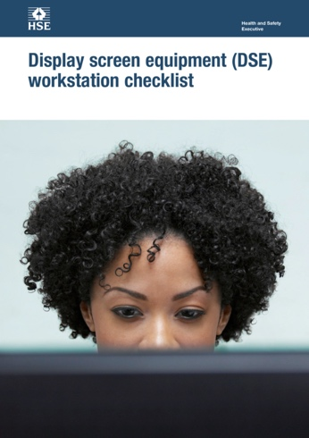

This is a web-friendly version of Display screen equipment (DSE) workstation checklist published 05/13

The following checklist can be used to help you complete a risk assessment and comply with the Schedule to the Health and Safety (Display Screen Equipment) Regulations 1992 as amended by the Health and Safety (Miscellaneous Amendments) Regulations 2002.
Any further action needed: Yes/No
Follow-up action completed on: .............................................
.............................................
.............................................
..............................................
.............................................
Workstation location and number (if applicable):
User: Checklist completed by:
Assessment checked by:

The questions and ‘Things to consider’ in the checklist cover the requirements of the Schedule. If you can answer ‘Yes’ in the second column against all the questions, having taken account of the ‘Things to consider’, you are complying. You will not be able to address some of the questions and ‘Things to consider’, eg on reflections on the screen, or the user’s comfort, until the workstation has been installed. These will be covered in the risk assessment you do once the workstation is installed.

Work through the checklist, ticking either the ‘Yes’ or ‘No’ column against each risk factor:
- ‘Yes’ answers require no further action.
- ‘No’ answers will require investigation and/or remedial action by the workstation assessor. They should record their decisions in the ‘Action to take’ column.
Assessors should check later that actions have been taken and have resolved the problem.

Remember, the checklist only covers the workstation and work environment. You also need to make sure that risks from other aspects of the work are avoided, eg by giving users health and safety training, and providing for breaks or changes of activity. For more advice on these see Working with display screen equipment (DSE): A brief guide.

Health and Safety Executive

1

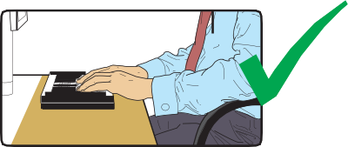
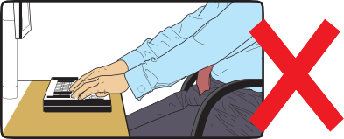
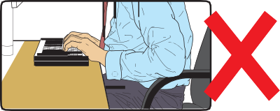
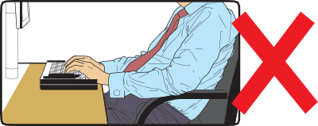
Risk factors | Tick answer |  | Things to consider | Action to take
 | Yes | No
1 Keyboards
Is the keyboard separate from the screen? |  |  | This is a requirement, unless the task makes it impracticable (eg where there is a need to use a portable).
Does the keyboard tilt? |  |  | Tilt need not be built in
Is it possible to find a comfortable keying position? |  |  | Try pushing the display screen further back to create more room for the keyboard, hands and wrists.  Users of thick, raised keyboards may need a wrist rest.
Does the user have good keyboard technique? |  |  | Training can be used to prevent:  - hands bent up at the wrist;  - hitting the keys too hard;  - overstretching the fingers.
Are the characters clear and readable? |  |  | Keyboards should be kept clean. If characters still can’t be read, the keyboard may need modifying or replacing.  Use a keyboard with a matt finish to reduce glare and/or reflection.

Risk factors | Tick answer |  | Things to consider | Action to take
 | Yes | No
2 Mouse, trackball etc
Is the device suitable for the tasks it is used for? |  |  | If the user is having problems, try a different device. The mouse and trackball are general-purpose devices suitable for many tasks, and available in a variety of shapes and sizes. Alternative devices such as touch screens may be better for some tasks (but can be worse for others).
Is the device positioned close to the user? |  |  | Most devices are best placed as close as possible, eg right beside the keyboard.  Training may be needed to:  - prevent arm overreaching;  - encourage users not to leave their hand on the device when it  is not being used;  - encourage a relaxed arm and straight wrist.
Is there support for the device user’s wrist and forearm? |  |  | Support can be gained from, for example, the desk surface or arm of a chair. If not, a separate supporting device may help.  The user should be able to find a comfortable working position with the device.
Does the device work smoothly at a speed that suits the user? |  |  | See if cleaning is required (eg of mouse ball and rollers).  Check the work surface is suitable. A mouse mat may be needed.
Can the user easily adjust software settings for speed and accuracy of pointer? |  |  | Users may need training in how to adjust device settings.

Risk factors | Tick answer |  | Things to consider | Action to take
 | Yes | No
3 Display screens
Are the characters clear and readable?  Health and safety  Health and safety |  |  | Make sure the screen is clean and cleaning materials are available.  Check that the text and background colours work well together.
Is the text size comfortable to read? |  |  | Software settings may need adjusting to change text size.
Is the image stable, ie free of flicker and jitter? |  |  | Try using different screen colours to reduce flicker, eg darker background and lighter text.  If there are still problems, get the set-up checked, eg by the equipment supplier.
Is the screen’s specification suitable for its intended use? |  |  | For example, intensive graphic work or work requiring fine attention to small details may require large display screens.
Are the brightness and/or contrast adjustable? |  |  | Separate adjustment controls are not essential, provided the user can read the screen easily at all times.
Does the screen swivel and tilt?  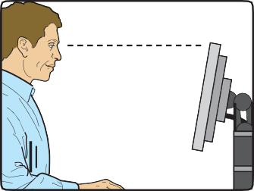 |  |  | Swivel and tilt need not be built in; you can add a swivel and tilt mechanism.  However, you may need to replace the screen if:  - swivel/tilt is absent or unsatisfactory;  - work is intensive; and/or  - the user has problems getting the screen to a comfortable  position.

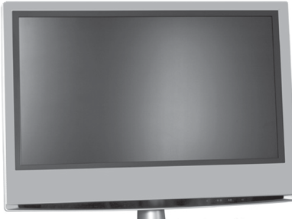
Risk factors | Tick answer |  | Things to consider | Action to take
 | Yes | No
Is the screen free from glare and reflections? |  |  | Use a mirror placed in front of the screen to check where reflections are coming from.  You might need to move the screen or even the desk and/or shield the screen from the source of the reflections.  Screens that use dark characters on a light background are less prone to glare and reflections.
Are adjustable window coverings provided and in adequate condition? |  |  | Check that blinds work. Blinds with vertical slats can be more suitable than horizontal ones.  If these measures do not work, consider anti-glare screen filters as a last resort and seek specialist help.
4 Software
Is the software suitable for the task? |  |  | Software should help the user carry out the task, minimise stress and be user-friendly.  Check users have had appropriate training in using the software.  Software should respond quickly and clearly to user input, with adequate feedback, such as clear help messages.

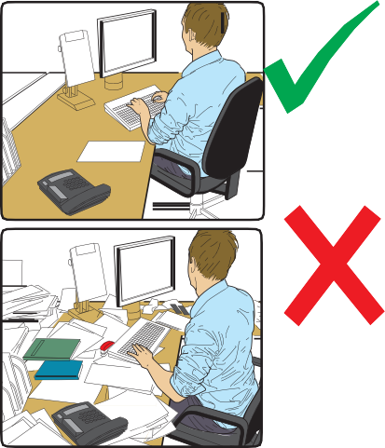
Risk factors | Tick answer |  | Things to consider | Action to take
 | Yes | No
5 Furniture
Is the work surface large enough for all the necessary equipment, papers etc? |  |  | Create more room by moving printers, reference materials etc elsewhere.  If necessary, consider providing new power and telecoms sockets, so equipment can be moved.  There should be some scope for flexible rearrangement.
Can the user comfortably reach all the equipment and papers they need to use? |  |  | Rearrange equipment, papers etc to bring frequently used things within easy reach.  A document holder may be needed, positioned to minimise uncomfortable head and eye movements.
Are surfaces free from glare and reflection? |  |  | Consider mats or blotters to reduce reflections and glare.
Is the chair suitable? Is the chair stable?  Does the chair have a working:  - seat back height and tilt adjustment?  - seat height adjustment?  - castors or glides? |  |  | The chair may need repairing or replacing if the user is uncomfortable, or cannot use the adjustment mechanisms.

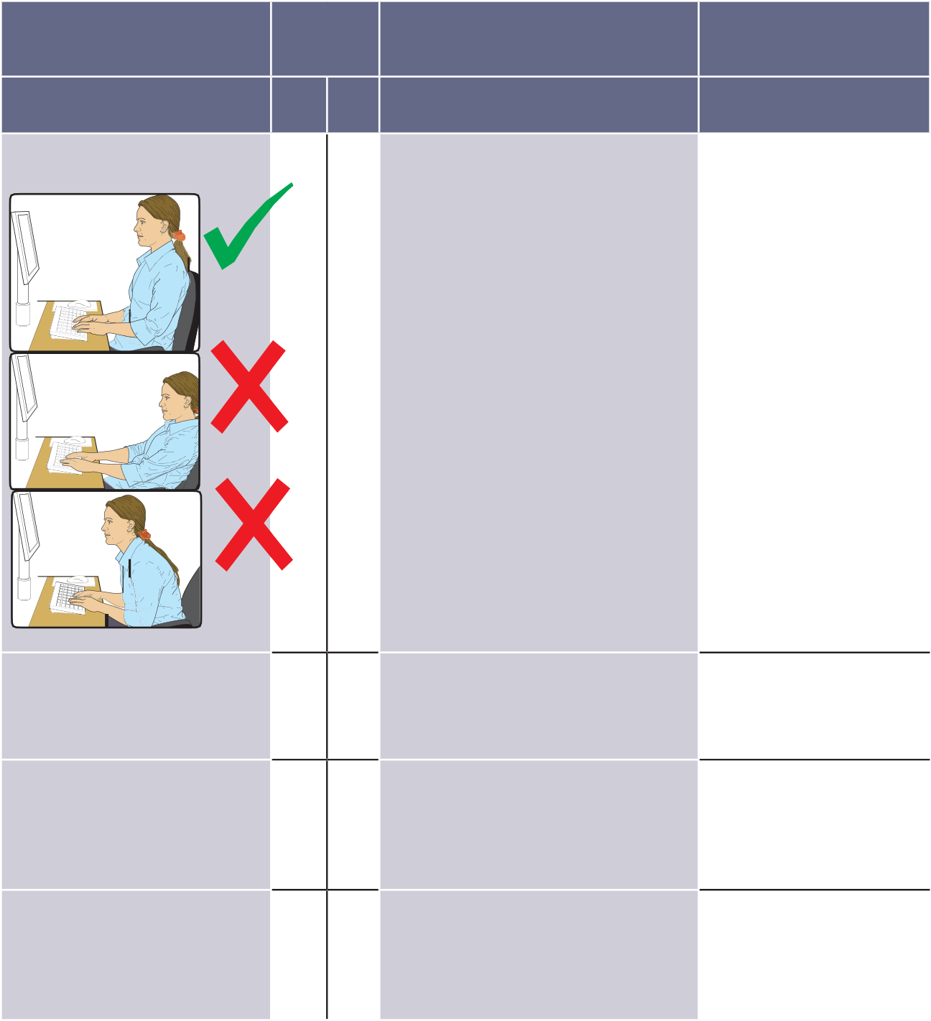
Risk factors
Tick answer
Things to consider
Action to take

Yes No

Is the chair adjusted correctly?
The user should be able to carry out their work sitting comfortably.

Consider training the user in how to adopt suitable postures while working.

The arms of chairs can stop the user getting close enough to use the equipment comfortably.

Move any obstructions from under the desk.

Is the small of the back supported by the chair’s backrest?

The user should have a straight back, supported by the chair, with relaxed shoulders.

Are forearms horizontal and eyes at roughly the same height as the top of the DSE?
Adjust the chair height to get the user’s arms in the right position, and then adjust the DSE height, if necessary.

Are feet flat on the floor, without too much pressure from the seat on the backs of the legs?
If not, a footrest may be needed.

Risk factors | Tick answer |  | Things to consider | Action to take
 | Yes | No
6 Environment
Is there enough room to change position and vary movement? |  |  | Space is needed to move, stretch and fidget.  Consider reorganising the office layout and check for obstructions.  Cables should be tidy and not a trip or snag hazard.
Is the lighting suitable, eg not too bright or too dim to work comfortably? |  |  | Users should be able to control light levels, eg by adjusting window blinds or light switches.  Consider shading or repositioning light sources or providing local lighting, eg desk lamps (but make sure lights don’t cause glare by reflecting off walls or other surfaces).
Does the air feel comfortable? |  |  | DSE and other equipment may dry the air.  Circulate fresh air if possible. Plants may help.  Consider a humidifier if discomfort is severe.
Are levels of heat comfortable? |  |  | Can heating be better controlled? More ventilation or air conditioning may be required if there is a lot of electronic equipment in the room. Or, can users be moved away from the heat source?
Are levels of noise comfortable? |  |  | Consider moving sources of noise, eg printers, away from the user. If not, consider soundproofing.

7 Final questions to users...

  - Has the checklist covered all the problems they may have working with their DSE?
  - Have they experienced any discomfort or other symptoms which they attribute to working with their DSE?
  - Has the user been advised of their entitlement to eye and eyesight testing?
  - Does the user take regular breaks working away from DSE?
Write down the details of any problems here:

Display screen equipment (DSE) workstation checklist

Further information
Working with display screen equipment (DSE): A brief guide Leaflet INDG36(rev4) HSE books 2013 www.hse.gov.uk/pubns/indg36.htm

For information about health and safety visit https://books.hse.gov.uk or http://www.hse.gov.uk. You can view HSE guidance online and order priced publications from the website. HSE priced publications are also available from bookshops.

To report inconsistencies or inaccuracies in this guidance email: commissioning@wlt.com

British Standards can be obtained in PDF or hard copy formats from BSI: http://shop.bsigroup.com or by contacting BSI Customer Services for hard copies only Tel: 0846 086 9001 Email: mailto:cservices@bsigroup.com
The Stationery Office publications are available from The Stationery Office, PO Box 29, Norwich NR3 1GN Tel: 0333 202 5070 Fax: 0333 202 5080.
Email: customer.services@tso.co.uk Website: http://www.tso.co.uk. They are
also available from bookshops.

Statutory Instruments can be viewed free of charge at http://www.legislation.gov.uk where you can also search for changes to legislation.

© Crown copyright 2013

First published 2013

ISBN 978 0 7176 6521 1

You may reuse this information (excluding logos) free of charge in any format or medium, under the terms of the Open Government Licence. To view the licence visit www.nationalarchives.gov.uk/doc/open-government-licence/, write to the Information Policy Team, The National Archives, Kew, London TW9 4DU, or email psi@nationalarchives.gsi.gov.uk.

Some images and illustrations may not be owned by the Crown so cannot be reproduced without permission of the copyright owner. Enquiries should be sent to copyright@hse.gsi.gov.uk.

This guidance is issued by the Health and Safety Executive. Following the guidance is not compulsory, unless specifically stated, and you are free to take other action. But if you do follow the guidance you will normally be doing enough to comply with the law. Health and safety inspectors seek to secure compliance with the law and may refer to this guidance.

10

